University of North Texas (UNT), CSCE 5430, Software Engineering

Deliverable 4, Item 2 of 15: UML Design (Phase 2)

Team Falcons, Lost and Found for Campus, CSCE 5430, Fall 2026

Working draft for team review. This section will be merged into the consolidated Deliverable 4 report once all 15 items are complete.

1. Overview

This section presents the three UML diagrams required for Deliverable 4: a class diagram showing the core domain classes and services implemented in Phase 2 (including Match, Claim, Message, and Notification entities alongside Phase 1's User and Listing classes), a sequence diagram showing the claim verification workflow from match suggestion through evidence submission, owner review, approval, and the opening of an in-app messaging channel, and a use case diagram showing how Claimant and Finder roles interact with the system, including match review, claim submission, claim review, messaging, and two error cases. All three diagrams were revised after an internal review to close gaps against the Phase 2 functional requirements in Deliverable 2 and against the Requirements, Phase 2 section of this deliverable.

2. Class Diagram

The class diagram below shows the Phase 2 domain model: the User and Listing entities from Phase 1, extended with four new classes: Match (the matching engine output), Claim (a claimant's evidence submission in response to a match), Message (individual messages in an in-app conversation thread), and Notification (pending delivery alerts). The diagram also shows the MatchingService, ClaimService, MessagingService, and NotificationService modules that implement the Phase 2 functional requirements (FR MATCH 01 through 03, FR CLM 01 through 03, FR COM 01 through 03, and FR NOTIF 01 through 02), and the MongoDB Atlas data access layer.

The Match class includes a score field (decimal, 0 to 1.0) representing the weighted match probability, and a scoreDetail object (private visibility) storing the component scores that generated the match. The Claim class includes evidence (text and optional images) and a status field (Pending, Approved, Rejected). Both Match and Claim maintain referential integrity through relationship references to the listing pair they represent.

The Message class stores individual message text, sender references, and a thread ID linking all messages in one conversation. The Notification class stores an event type (MatchFound, ClaimSubmitted, ClaimApproved, ClaimRejected, NewMessage), the affected listing or claim, the recipient user ID, and delivery status (Pending, SentInApp, SentEmail, Failed).

All private fields follow the same privacy model established in Phase 1: scoreDetail, claim evidence, passwords, tokens, and message contents are private and excluded from public responses.

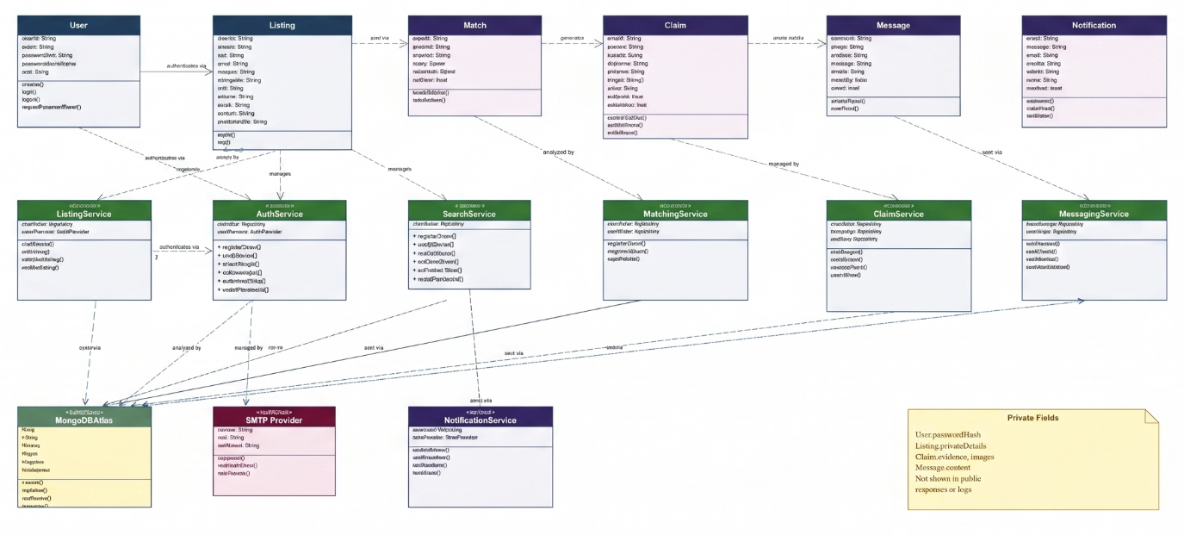

Figure 1. Class diagram for Phase 2, showing the User, Listing, Match, Claim, Message, and Notification entities, the Matching, Claim, Messaging, and Notification services, the MongoDB Atlas data access layer, and the private fields required by claim evidence and notification privacy requirements.

3. Sequence Diagram

The sequence diagram below traces the Phase 2 claim verification workflow: a claimant receives a match notification and opens the claim submission form, submits evidence (description and optional images) to the ClaimService, the owner receives a claim review notification and compares the evidence against their private listing details, the owner approves or rejects the claim, and approval triggers the MessagingService to open a one-on-one message thread.

The diagram shows three paths through the workflow: a successful evidence submission path, a valid owner review and approval path that opens messaging, and an evidence rejection path that leaves the listing Active for other claimants. The sequence shows message exchange between the React web client, the ClaimService, and NotificationService modules of the Express API, and MongoDB Atlas. Notification events are asynchronous calls to the NotificationService, which queues delivery tasks rather than blocking the primary workflow.

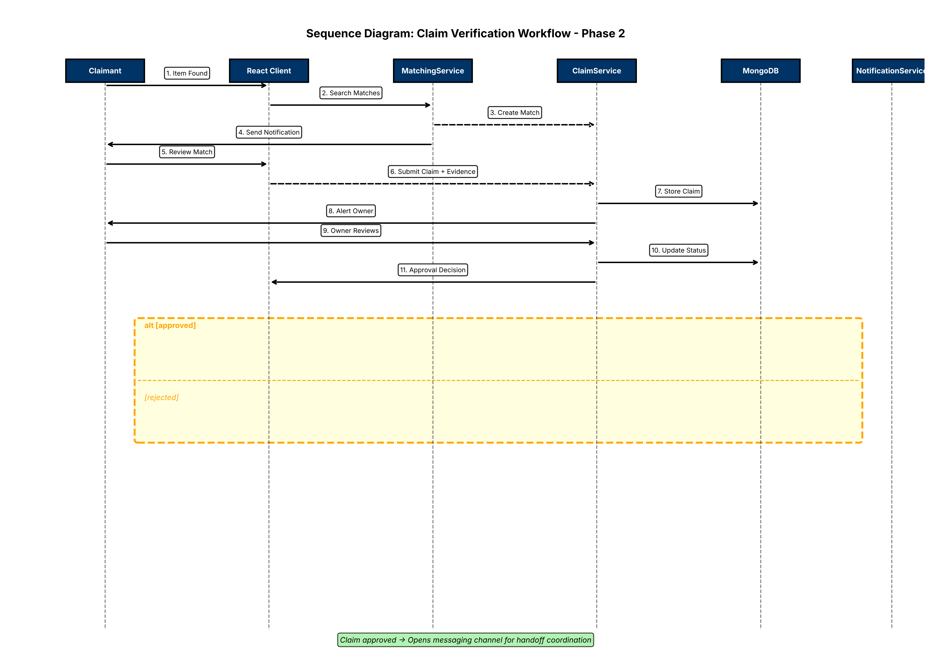

Figure 2. Sequence diagram for the Phase 2 claim verification workflow, including match notification receipt, evidence submission, owner review, and the approval or rejection branches. Approval outcomes in opening a messaging thread between Claimant and Finder; rejection keeps the listing Active.

4. Use Case Diagram

The use case diagram below shows how Claimant and Finder roles interact with the Lost and Found system in Phase 2. A Claimant is an authenticated user who has received a match notification and is responding to it. A Finder is the original poster of a Found listing. Both roles extend the Registered User role from Phase 1, so they retain the ability to browse, search, and manage their own listings in addition to Phase 2 claim and messaging workflows.

Normal case: a claimant receives a match notification, reviews the listing details and private identifying information, and submits evidence in response. The Submit Claim use case includes Validate Claim Evidence and Verify Authentication before evidence is accepted.

Error case 1, invalid evidence: the Display Validation Error use case extends Submit Claim whenever submitted evidence is incomplete or images exceed the configured size limit, so the action is stopped instead of completing.

Error case 2, owner review failure: the Reject Claim use case extends the Review Claim flow whenever the owner rejects evidence, keeping the listing Active for other claimants to respond to.

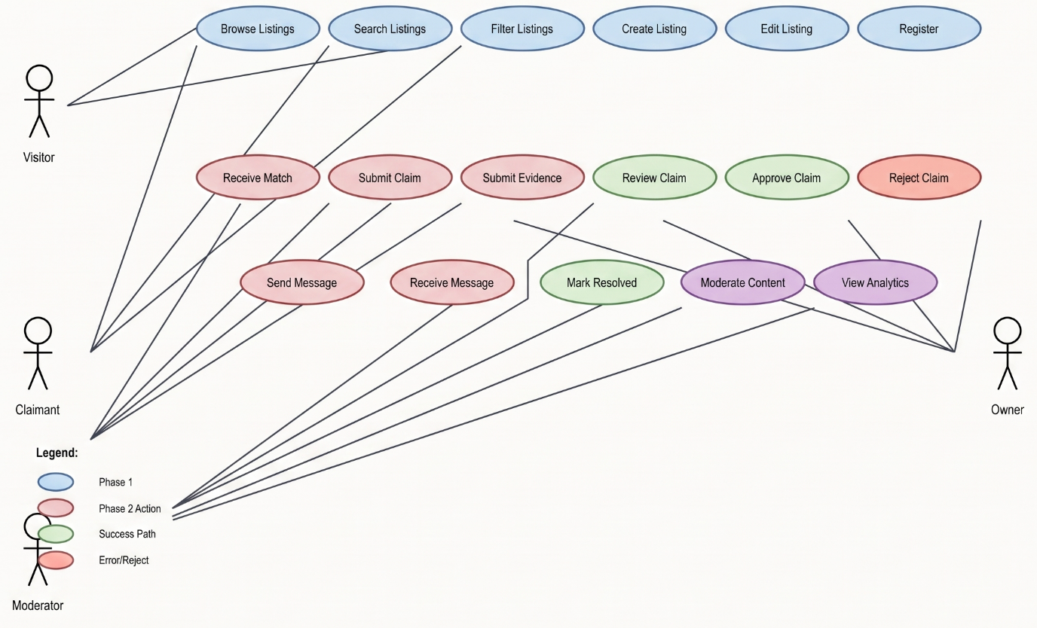

Figure 3. Use case diagram for Phase 2, showing the Claimant and Finder roles, the match notification and claim workflows, successful claim review and approval opening a messaging thread, invalid evidence validation errors, and the claim rejection path.

